**Chapter 7**

**Result**

**Result for a particular day:**

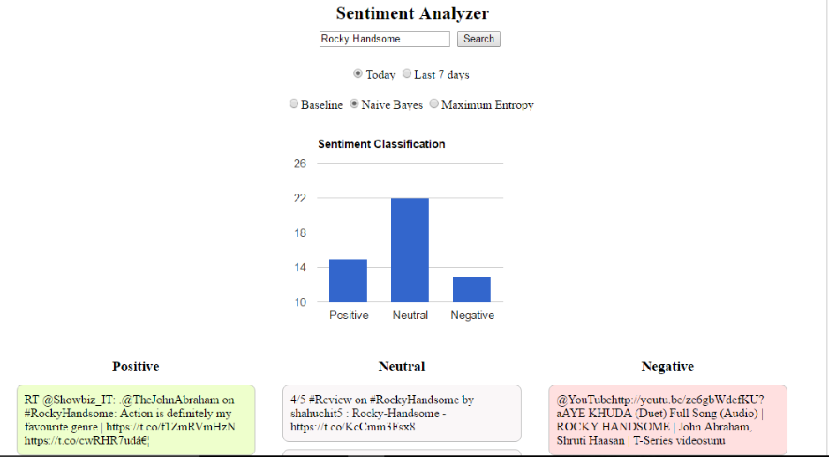

**Fig.7.1 Naïve Bayes-I**

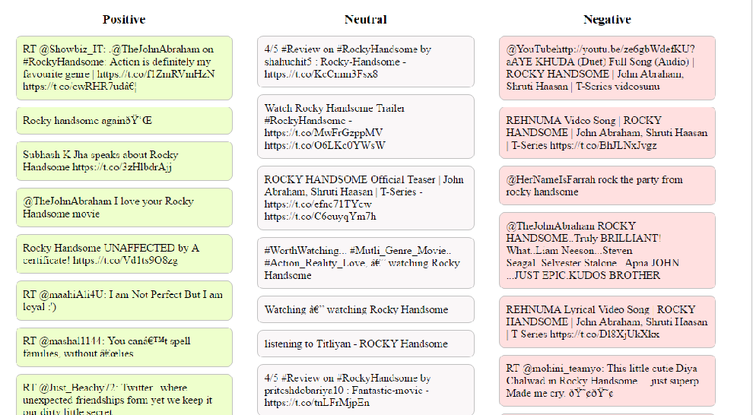

**Fig.7.2 Naïve Bayes-II**

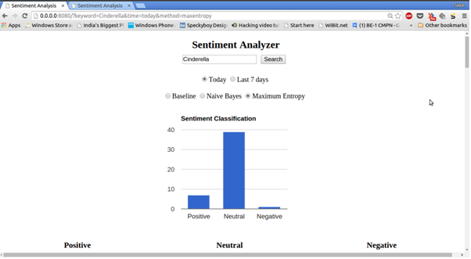

**Fig.7.3 Maximum Entropy-I**

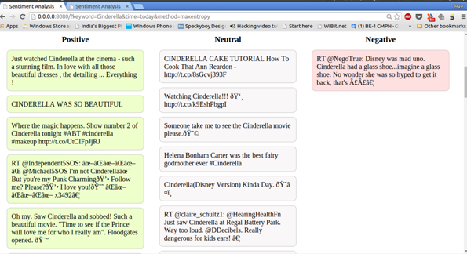

**Fig.7.4 Maximum Entropy-II**

**Result for one week:**

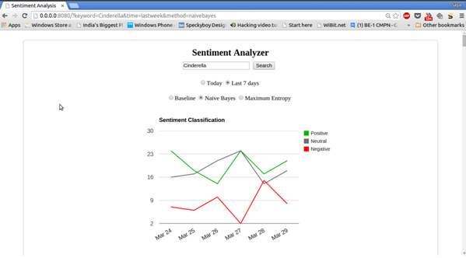

**Fig.7.5 Naïve Bayes-I**

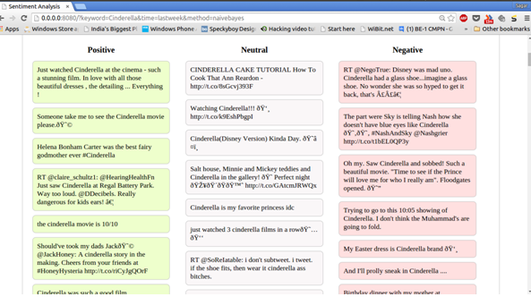

**Fig.7.6Naïve Bayes-II**